Divide and Conquer – Searching & Basic Problems
Binary Search, Finding Maximum and Minimum using Divide and Conquer
Dr. U. Samson Ebenezar

Question 1: Search an Element in a Sorted Array
Given a sorted array of integers and a key value, use the Binary Search (Divide and Conquer) method to determine whether the key is present in the array. If found, print its position; otherwise, print "Element not found".
Test Case 1
Input
5
10 20 30 40 50
30
Expected Output
Element found at position 3
Test Case 2
Input
5
10 20 30 40 50
25
Expected Output
Element not found

Question 2: Find the Index of a Given Number
Given a sorted array and a target number, find the index of the target using Binary Search. Assume array indexing starts from 0.
Test Case 1
Input
6
2 4 6 8 10 12
8
Expected Output
Index = 3

Test Case 2
Input
6
2 4 6 8 10 12
5
Expected Output
Index = -1

Question 3: Count the Number of Iterations in Binary Search
Given a sorted array and a key, perform Binary Search and display the number of iterations required to find the element.
Test Case 1
Input
7
5 10 15 20 25 30 35
25
Expected Output
Element found
Iterations = 2
Test Case 2
Input
7
5 10 15 20 25 30 35
40
Expected Output
Element not found
Iterations = 3

Question 4: Find the First Occurrence of an Element
Given a sorted array containing duplicate elements, find the first occurrence of a given key using Binary Search.
Test Case 1
Input
8
1 2 2 2 3 4 5 6
2
Expected Output
First occurrence at index 1
Test Case 2
Input
8
1 2 2 2 3 4 5 6
7
Expected Output
Element not found

Question 5: Find the Last Occurrence of an Element
Given a sorted array containing duplicate elements, find the last occurrence of a given key using Binary Search.
Test Case 1
Input
8
1 2 2 2 3 4 5 6
2
Expected Output
Last occurrence at index 3
Test Case 2
Input
8
1 2 2 2 3 4 5 6
9
Expected Output
Element not found
Question 6: Highest and Lowest Temperature Recorded
A weather station records temperatures over a week. Find the minimum and maximum temperature using the Divide and Conquer approach.
Input
7
32 28 35 25 31 29 37
Expected Output
Minimum Temperature = 25
Maximum Temperature = 37

Question 6: Best and Worst Student Marks
A teacher wants to identify the highest and lowest marks scored in a class using Divide and Conquer.
Input
8
78 92 65 88 95 72 81 69
Expected Output
Minimum Mark = 65
Maximum Mark = 95

Question 8: Stock Price Analysis
An investor wants to know the minimum and maximum stock prices recorded during a trading week.
Input
6
450 520 480 610 430 590
Expected Output
Minimum Stock Price = 430
Maximum Stock Price = 610

Question 9: Fastest and Slowest Race Times
A sports analyst needs to find the fastest (minimum) and slowest (maximum) race completion times.
Input
9
14 12 18 11 15 13 17 16 10
Expected Output
Fastest Time = 10
Slowest Time = 18

Question 10: Largest and Smallest Building Heights
An urban planner is analyzing building heights in a city block and wants to determine the tallest and shortest buildings.
Input
10
120 150 98 175 140 165 110 190 130 145
Expected Output
Minimum Height = 98
Maximum Height = 190

1. def binary_search(arr, key):
low = 0
high = len(arr) - 1

while low <= high:
mid = (low + high) // 2

if arr[mid] == key:
return mid + 1 # Position (1-based indexing)
elif arr[mid] < key:
low = mid + 1
else:
high = mid - 1

return -1

# Input
n = int(input("Enter number of elements: "))
arr = list(map(int, input("Enter sorted elements: ").split()))
key = int(input("Enter key to search: "))

# Search
result = binary_search(arr, key)

# Output
if result != -1:
print("Element found at position", result)
else:
print("Element not found")

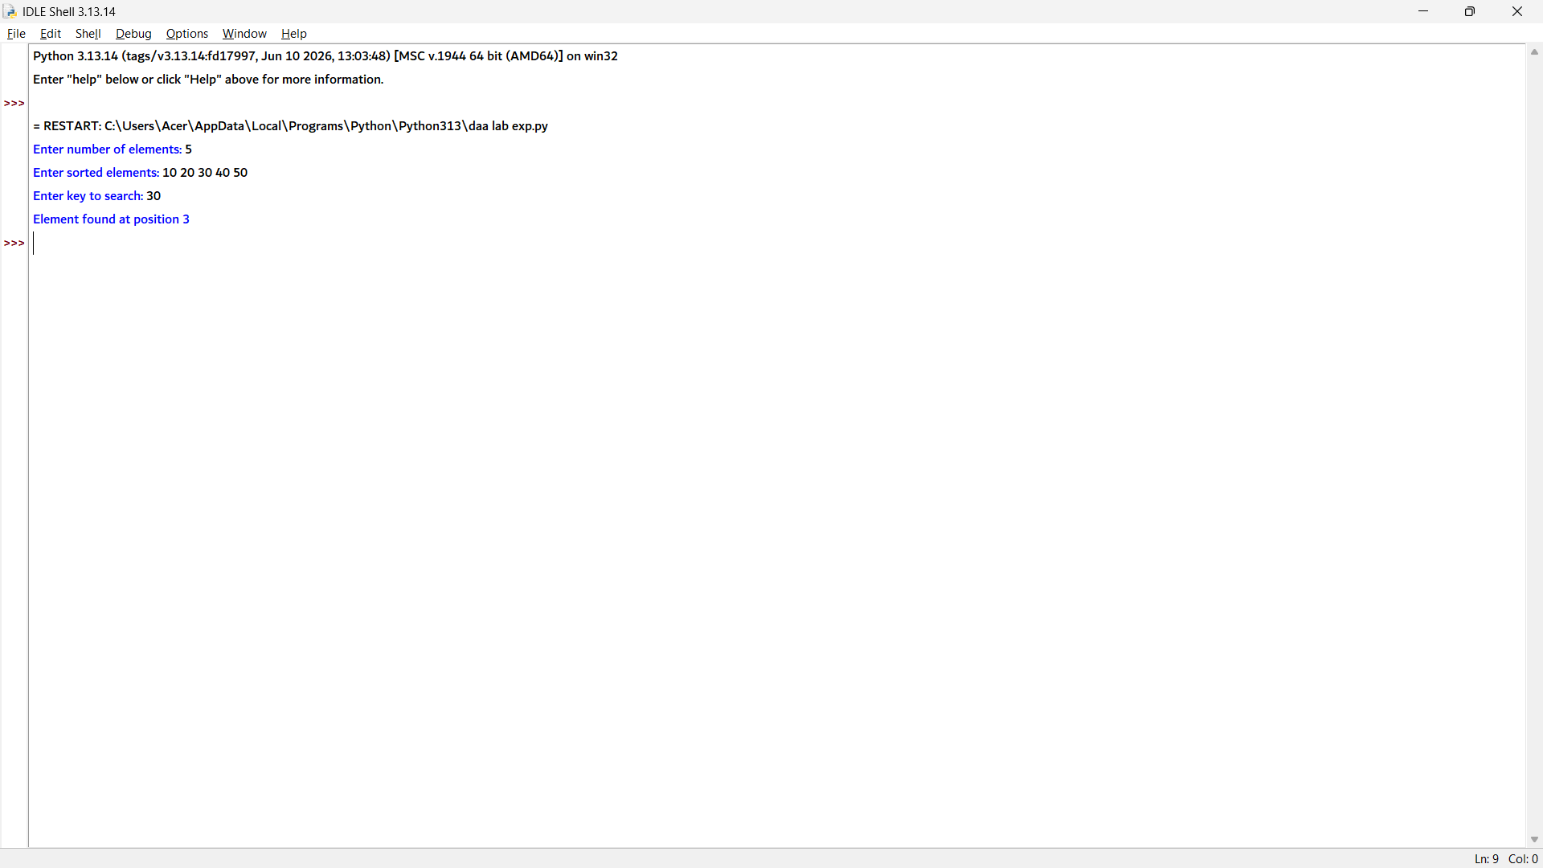

2. def binary_search(arr, key):
low = 0
high = len(arr) - 1

while low <= high:
mid = (low + high) // 2

if arr[mid] == key:
return mid # Return 0-based index
elif arr[mid] < key:
low = mid + 1
else:
high = mid - 1

return -1

# Input
n = int(input("Enter number of elements: "))
arr = list(map(int, input("Enter sorted elements: ").split()))
key = int(input("Enter target number: "))

# Search
index = binary_search(arr, key)

# Output
print("Index =", index)

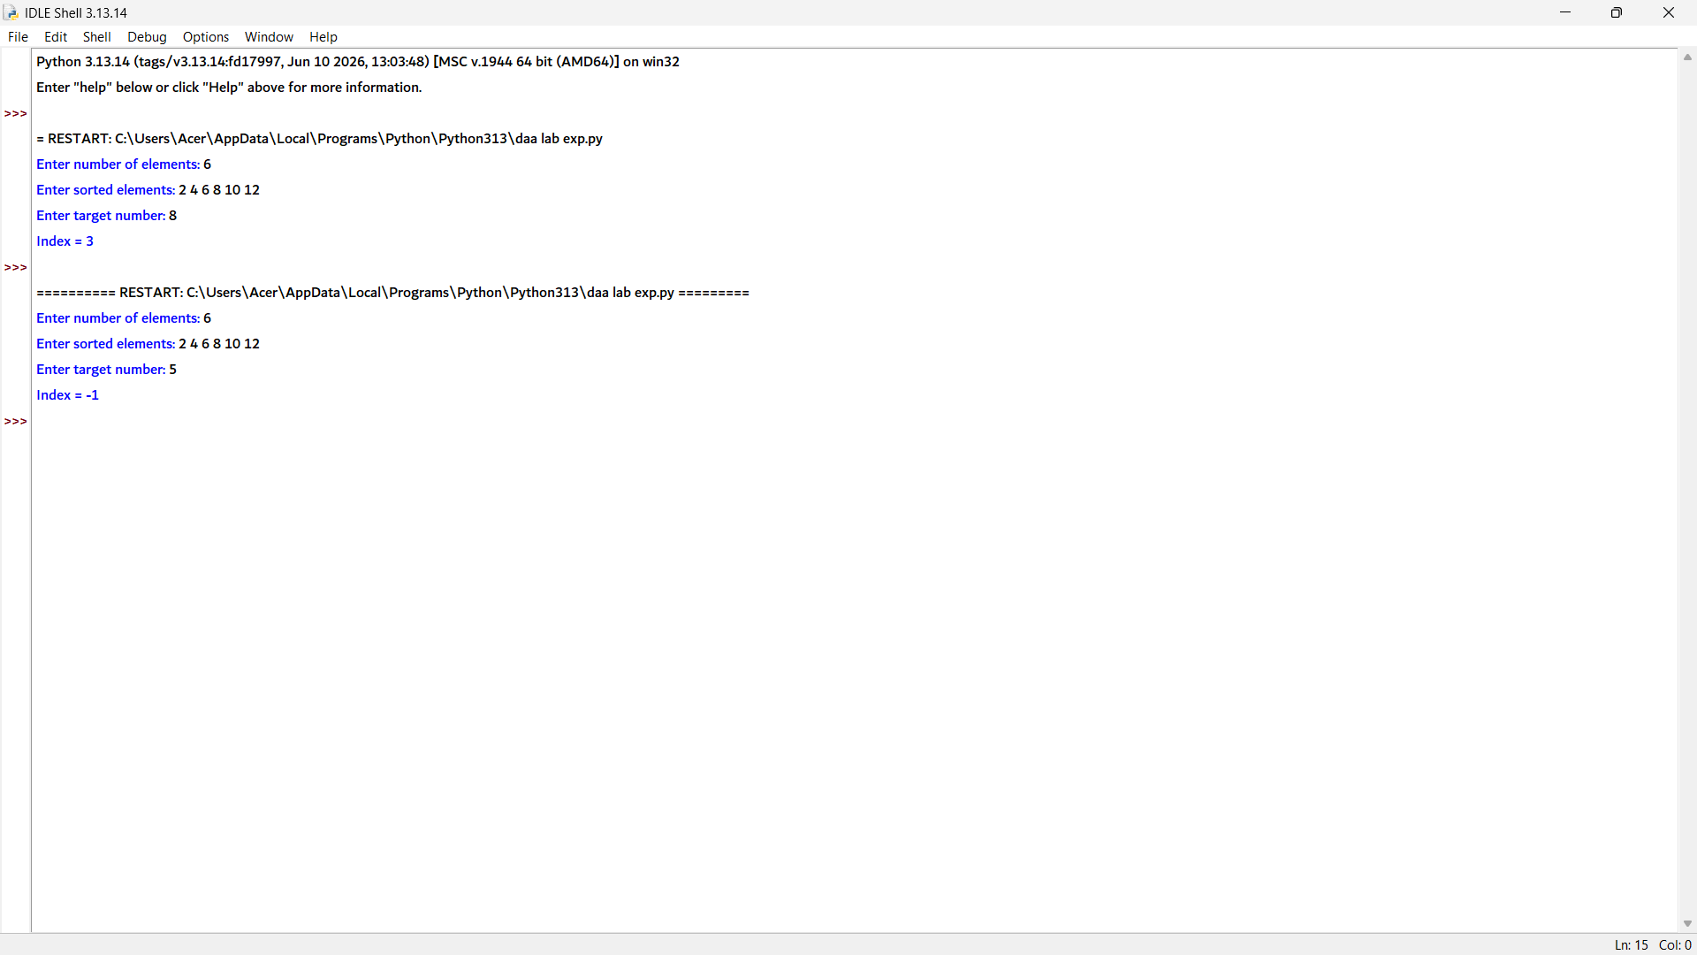

3. def binary_search(arr, key):
low = 0
high = len(arr) - 1
iterations = 0

while low <= high:
iterations += 1
mid = (low + high) // 2

if arr[mid] == key:
return True, iterations
elif arr[mid] < key:
low = mid + 1
else:
high = mid - 1

return False, iterations

# Input
n = int(input("Enter number of elements: "))
arr = list(map(int, input("Enter sorted elements: ").split()))
key = int(input("Enter key: "))

# Search
found, iterations = binary_search(arr, key)

# Output
if found:
print("Element found")
else:
print("Element not found")

print("Iterations =", iterations)

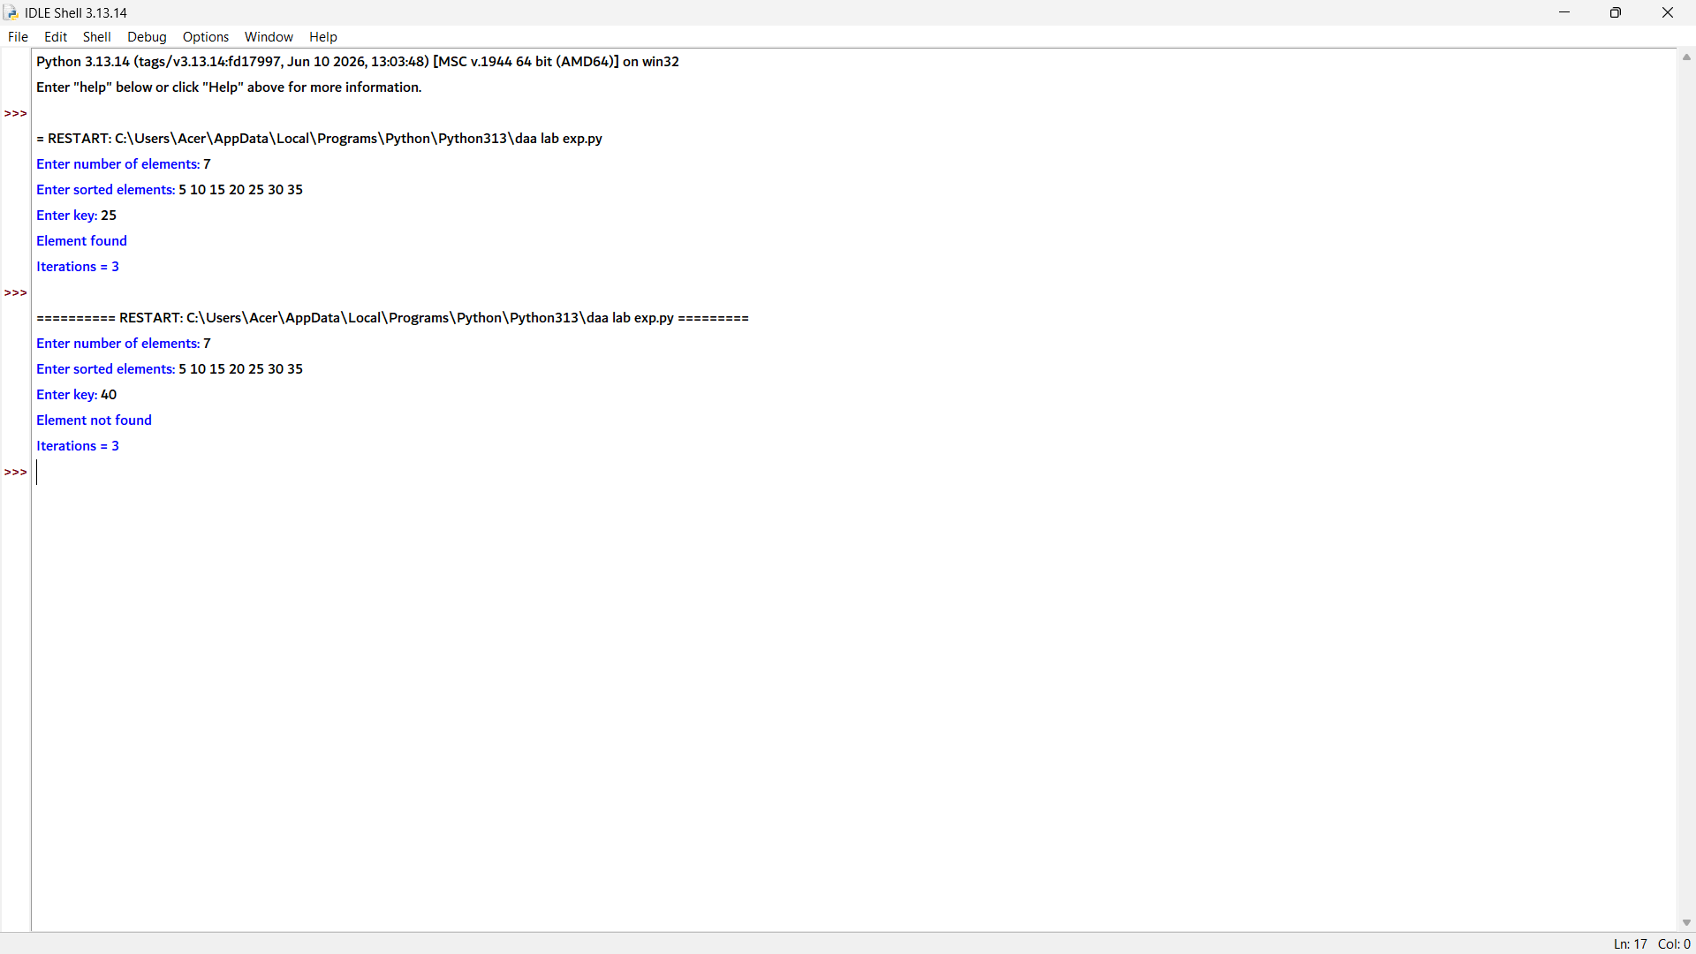

4. def first_occurrence(arr, key):
low = 0
high = len(arr) - 1
result = -1

while low <= high:
mid = (low + high) // 2

if arr[mid] == key:
result = mid
high = mid - 1 # Continue searching on the left side
elif arr[mid] < key:
low = mid + 1
else:
high = mid - 1

return result

# Input
n = int(input("Enter number of elements: "))
arr = list(map(int, input("Enter sorted elements: ").split()))
key = int(input("Enter key: "))

# Search
index = first_occurrence(arr, key)

# Output
if index != -1:
print("First occurrence at index", index)
else:
print("Element not found")

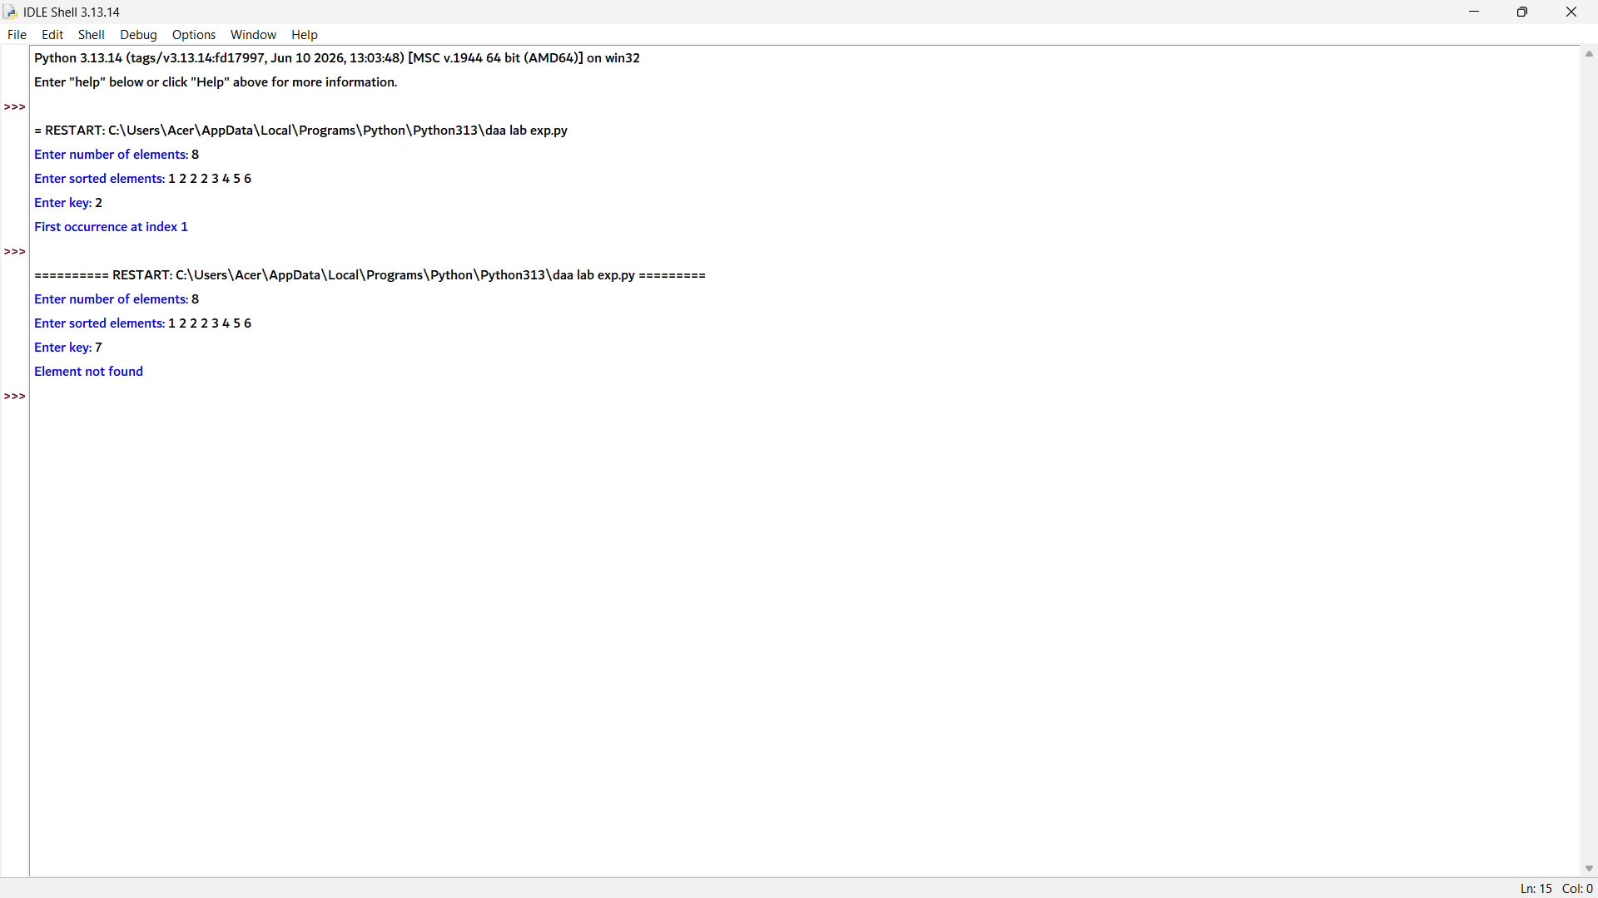

5. def last_occurrence(arr, key):
low = 0
high = len(arr) - 1
result = -1

while low <= high:
mid = (low + high) // 2

if arr[mid] == key:
result = mid
low = mid + 1 # Continue searching on the right side
elif arr[mid] < key:
low = mid + 1
else:
high = mid - 1

return result

# Input
n = int(input("Enter number of elements: "))
arr = list(map(int, input("Enter sorted elements: ").split()))
key = int(input("Enter key: "))

# Search
index = last_occurrence(arr, key)

# Output
if index != -1:
print("Last occurrence at index", index)
else:
print("Element not found")

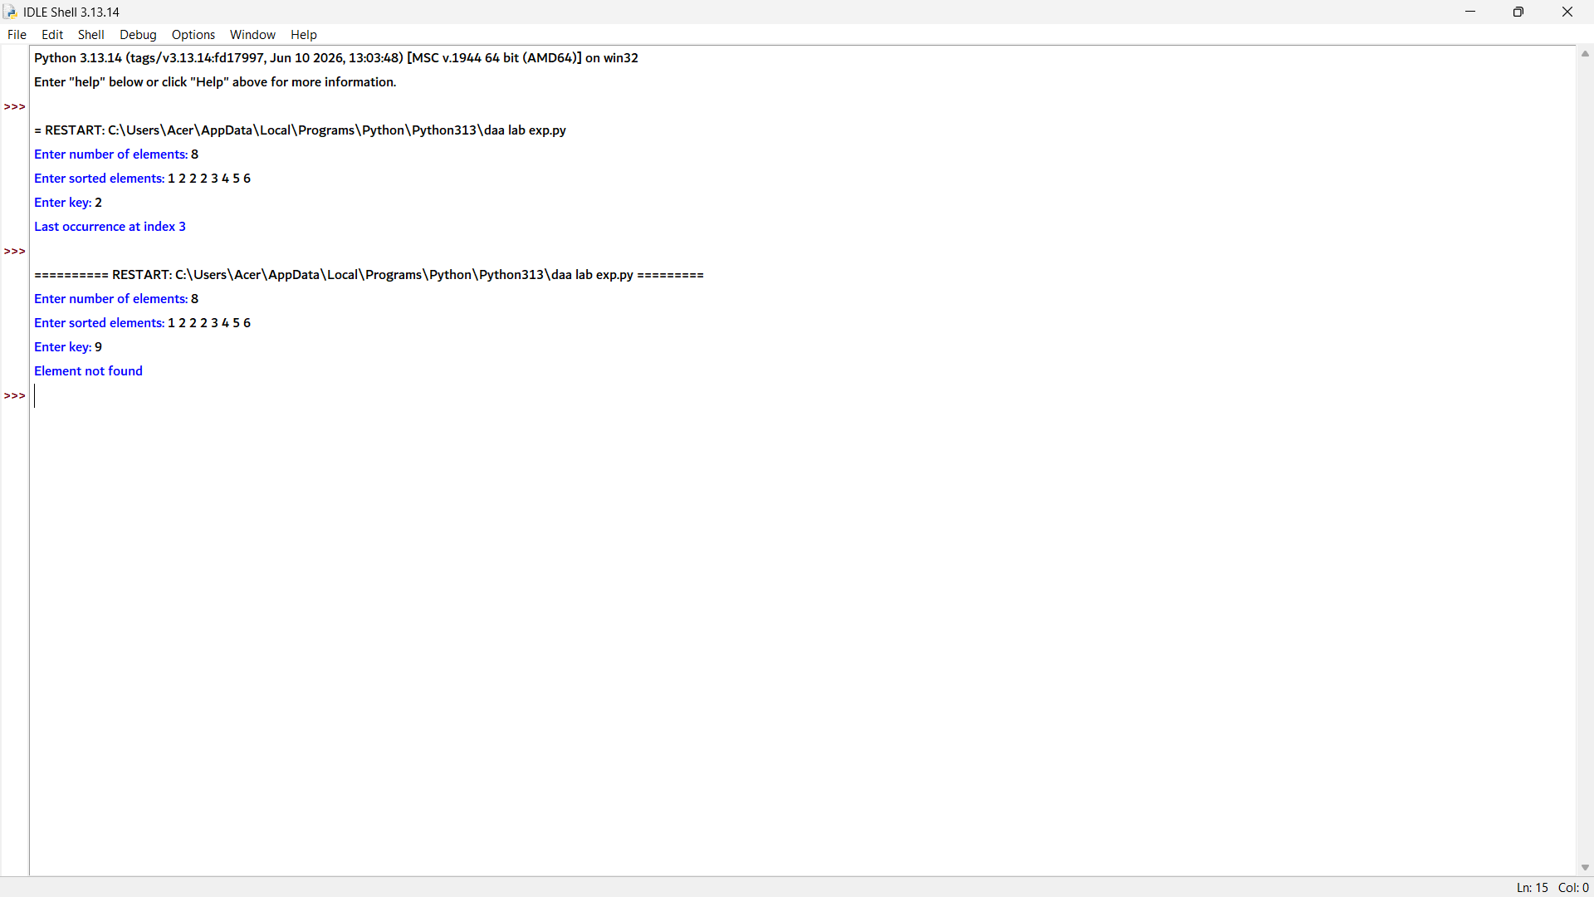

6. # Function to find minimum and maximum using Divide and Conquer
def find_min_max(arr, low, high):
# Only one element
if low == high:
return arr[low], arr[low]

# Two elements
if high == low + 1:
if arr[low] < arr[high]:
return arr[low], arr[high]
else:
return arr[high], arr[low]

# Divide the array
mid = (low + high) // 2

min1, max1 = find_min_max(arr, low, mid)
min2, max2 = find_min_max(arr, mid + 1, high)

# Combine results
minimum = min(min1, min2)
maximum = max(max1, max2)

return minimum, maximum

# Input
n = int(input("Enter number of temperatures: "))
arr = list(map(int, input("Enter temperatures: ").split()))

# Find minimum and maximum
minimum, maximum = find_min_max(arr, 0, n - 1)

# Output
print("Minimum Temperature =", minimum)
print("Maximum Temperature =", maximum)

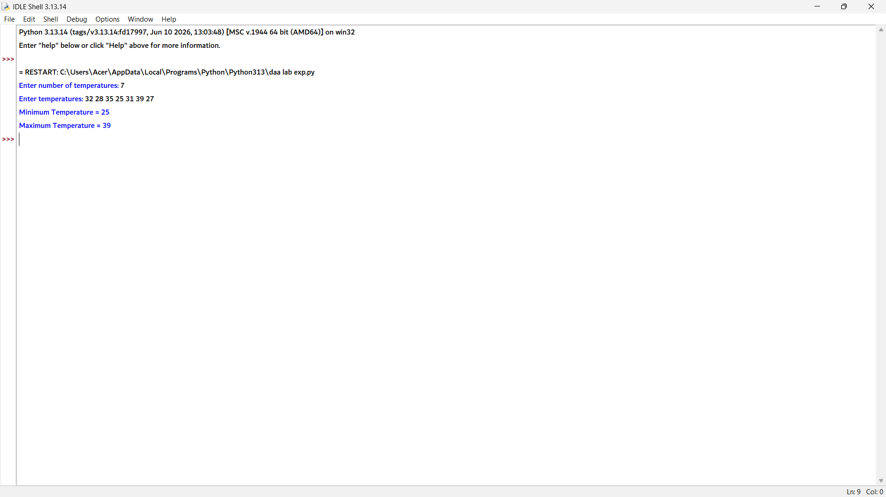

7. # Function to find minimum and maximum using Divide and Conquer
def find_min_max(arr, low, high):

# If only one element
if low == high:
return arr[low], arr[low]

# If two elements
if high == low + 1:
if arr[low] < arr[high]:
return arr[low], arr[high]
else:
return arr[high], arr[low]

# Divide the array
mid = (low + high) // 2

min1, max1 = find_min_max(arr, low, mid)
min2, max2 = find_min_max(arr, mid + 1, high)

# Combine results
minimum = min(min1, min2)
maximum = max(max1, max2)

return minimum, maximum

# Input
n = int(input("Enter number of students: "))
marks = list(map(int, input("Enter marks: ").split()))

# Find minimum and maximum marks
minimum, maximum = find_min_max(marks, 0, n - 1)

# Output
print("Minimum Mark =", minimum)
print("Maximum Mark =", maximum)

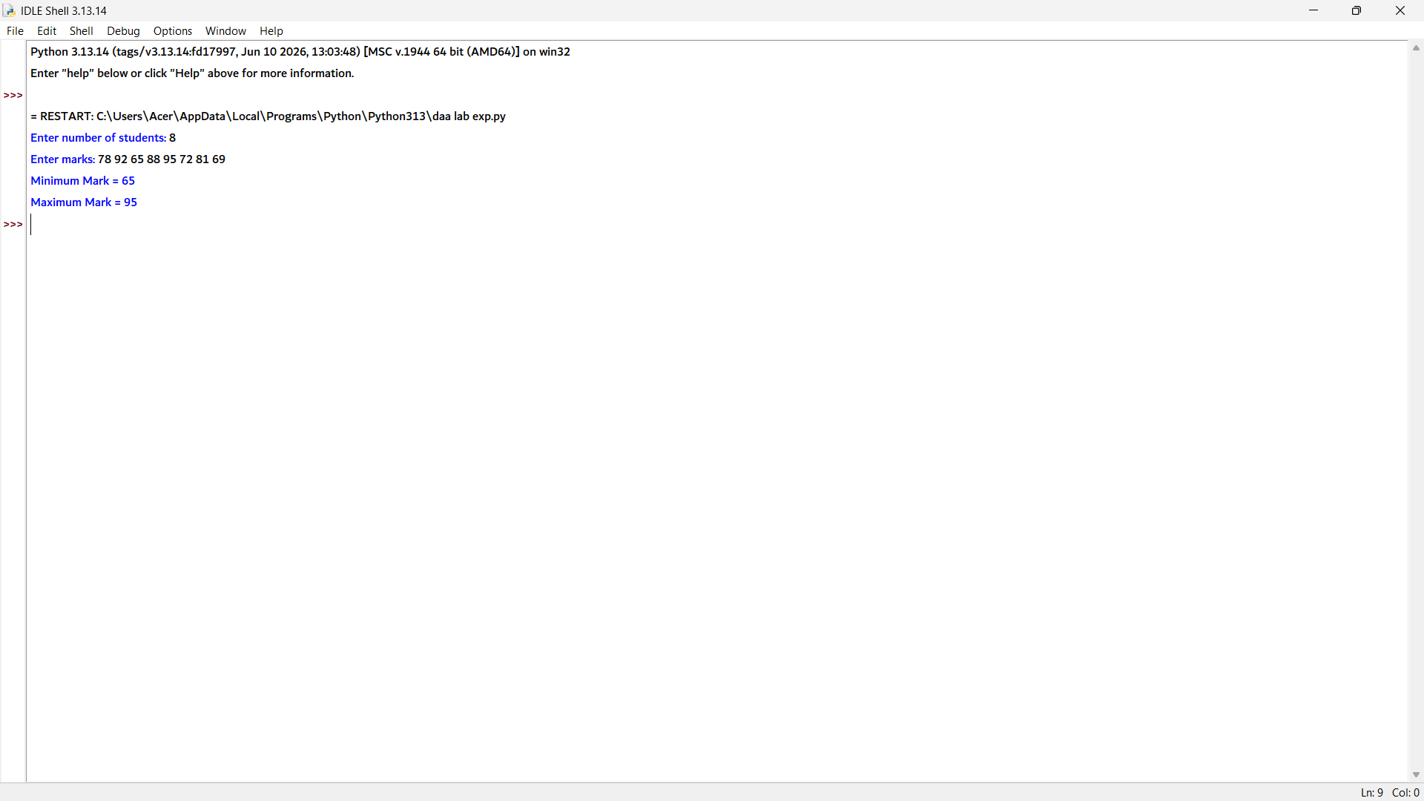

8. # Function to find minimum and maximum using Divide and Conquer
def find_min_max(arr, low, high):

# If only one element
if low == high:
return arr[low], arr[low]

# If two elements
if high == low + 1:
if arr[low] < arr[high]:
return arr[low], arr[high]
else:
return arr[high], arr[low]

# Divide the array
mid = (low + high) // 2

min1, max1 = find_min_max(arr, low, mid)
min2, max2 = find_min_max(arr, mid + 1, high)

# Combine the results
minimum = min(min1, min2)
maximum = max(max1, max2)

return minimum, maximum

# Input
n = int(input("Enter number of stock prices: "))
prices = list(map(int, input("Enter stock prices: ").split()))

# Find minimum and maximum stock prices
minimum, maximum = find_min_max(prices, 0, n - 1)

# Output
print("Minimum Stock Price =", minimum)
print("Maximum Stock Price =", maximum)

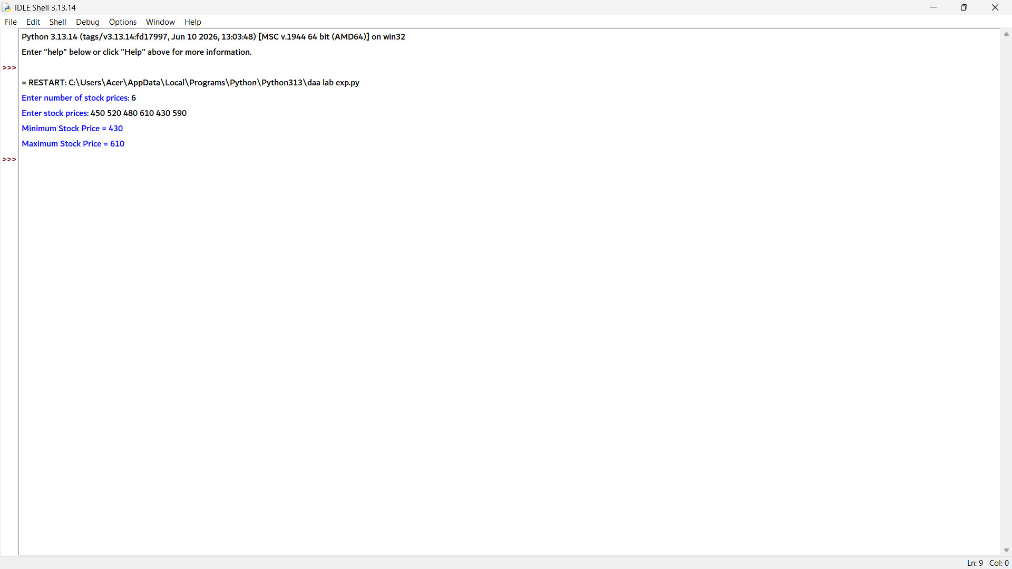

9. # Function to find minimum and maximum using Divide and Conquer
def find_min_max(arr, low, high):

# If only one element
if low == high:
return arr[low], arr[low]

# If two elements
if high == low + 1:
if arr[low] < arr[high]:
return arr[low], arr[high]
else:
return arr[high], arr[low]

# Divide the array
mid = (low + high) // 2

min1, max1 = find_min_max(arr, low, mid)
min2, max2 = find_min_max(arr, mid + 1, high)

# Combine the results
minimum = min(min1, min2)
maximum = max(max1, max2)

return minimum, maximum

# Input
n = int(input("Enter number of race times: "))
times = list(map(int, input("Enter race times: ").split()))

# Find fastest and slowest times
minimum, maximum = find_min_max(times, 0, n - 1)

# Output
print("Fastest Time =", minimum)
print("Slowest Time =", maximum)

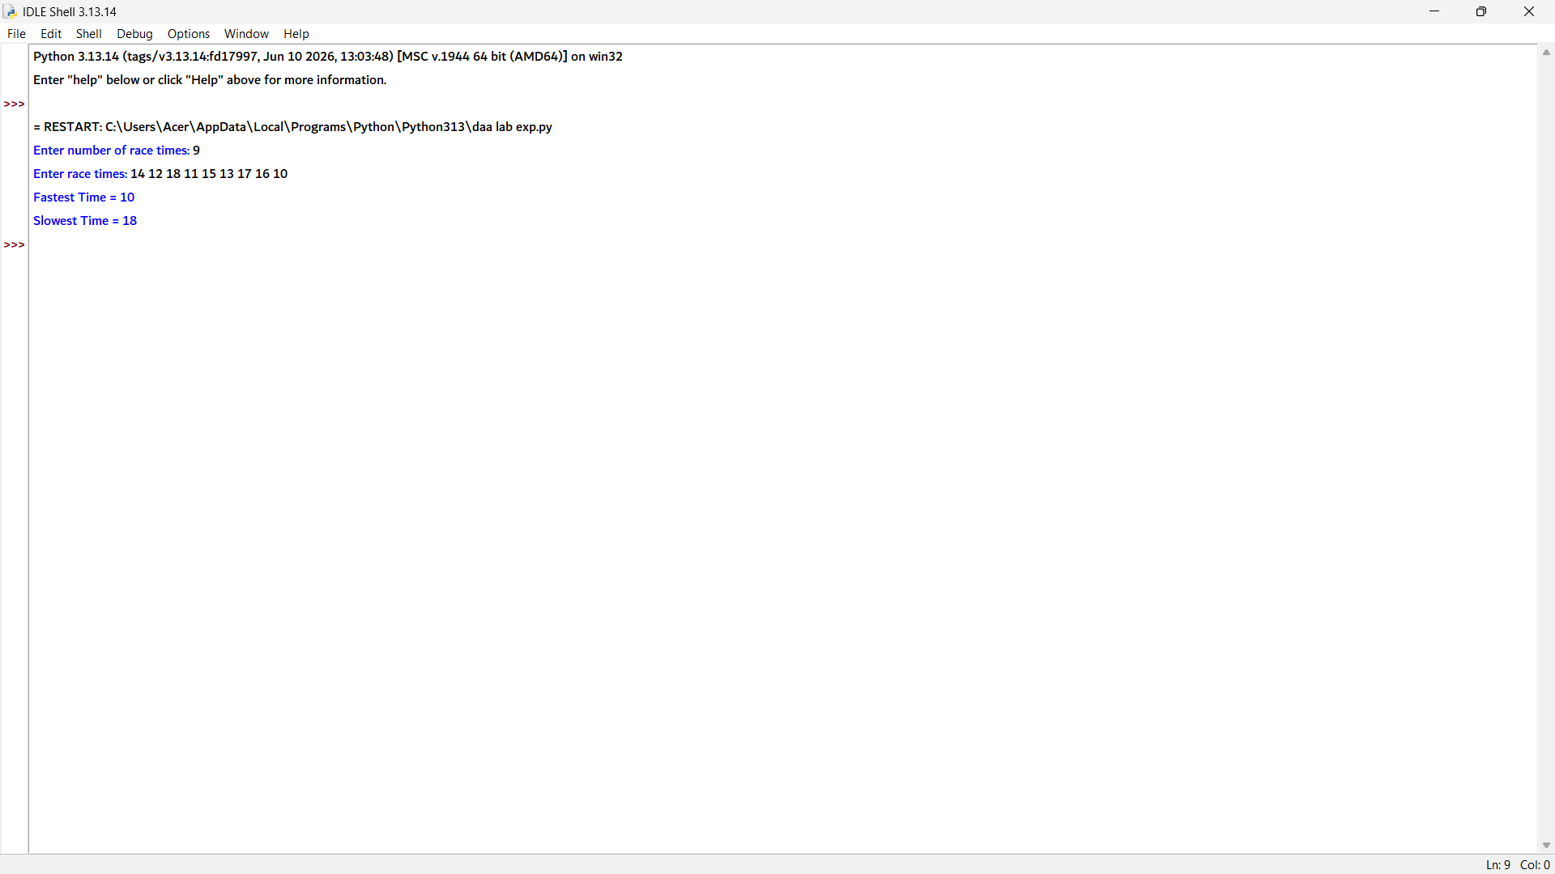

10 # Function to find minimum and maximum using Divide and Conquer
def find_min_max(arr, low, high):

# If only one element
if low == high:
return arr[low], arr[low]

# If two elements
if high == low + 1:
if arr[low] < arr[high]:
return arr[low], arr[high]
else:
return arr[high], arr[low]

# Divide the array
mid = (low + high) // 2

min1, max1 = find_min_max(arr, low, mid)
min2, max2 = find_min_max(arr, mid + 1, high)

# Combine the results
minimum = min(min1, min2)
maximum = max(max1, max2)

return minimum, maximum

# Input
n = int(input("Enter number of buildings: "))
heights = list(map(int, input("Enter building heights: ").split()))

# Find minimum and maximum heights
minimum, maximum = find_min_max(heights, 0, n - 1)

# Output
print("Minimum Height =", minimum)
print("Maximum Height =", maximum)

